**COGNIZANT**

**Week-2 Hands on**

**Assignments**

**PL SQL, Unit testing**

**Name: *Lalith Kumar S***

**Super Set ID: *6372999***

**E-mail:**[***officiallalithkumar@gmail.com***](mailto:officiallalithkumar@gmail.com)

**PL SQL**

**Question-1(Control structures)**

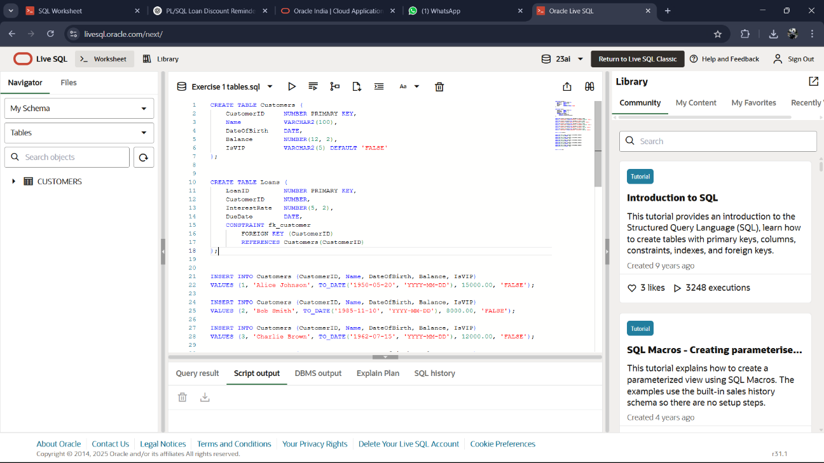**Create Table**

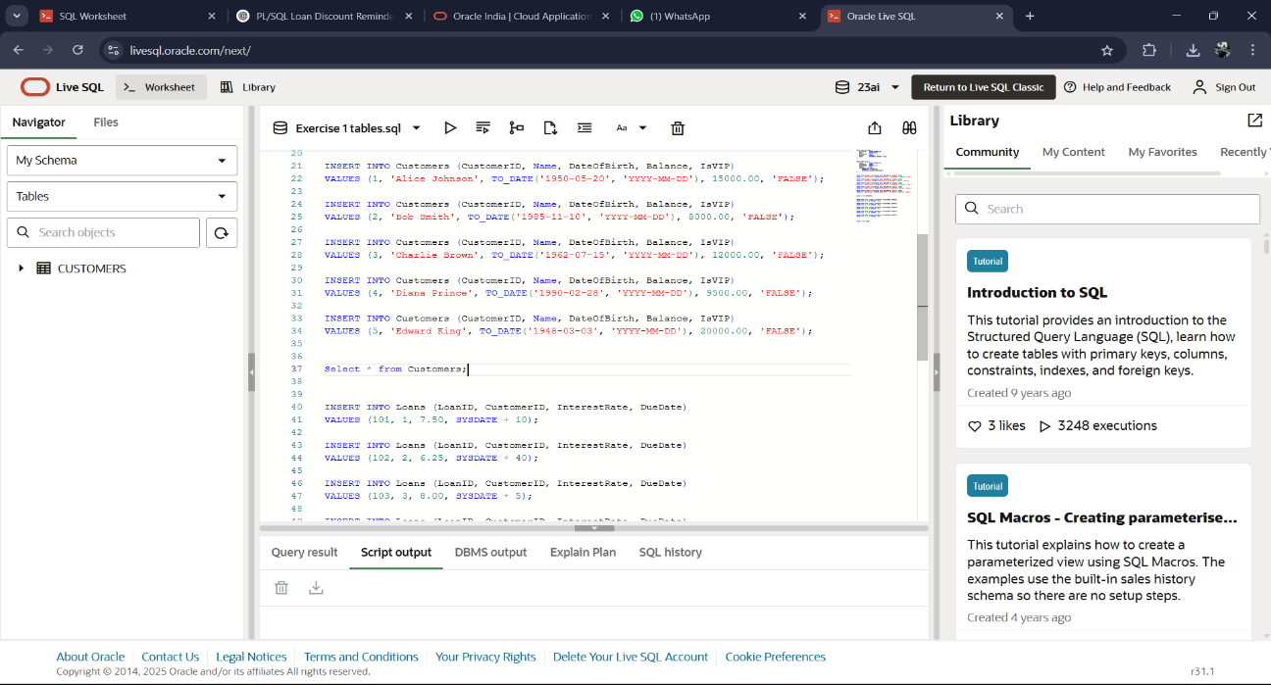

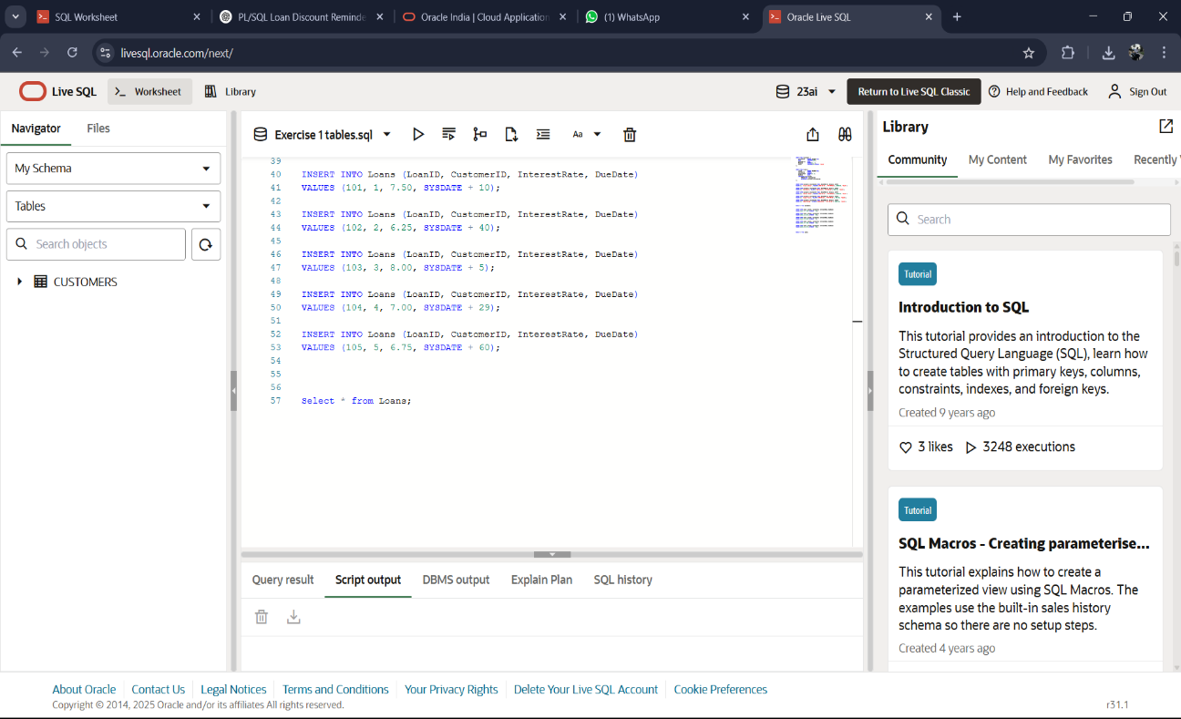

**Senario-1**

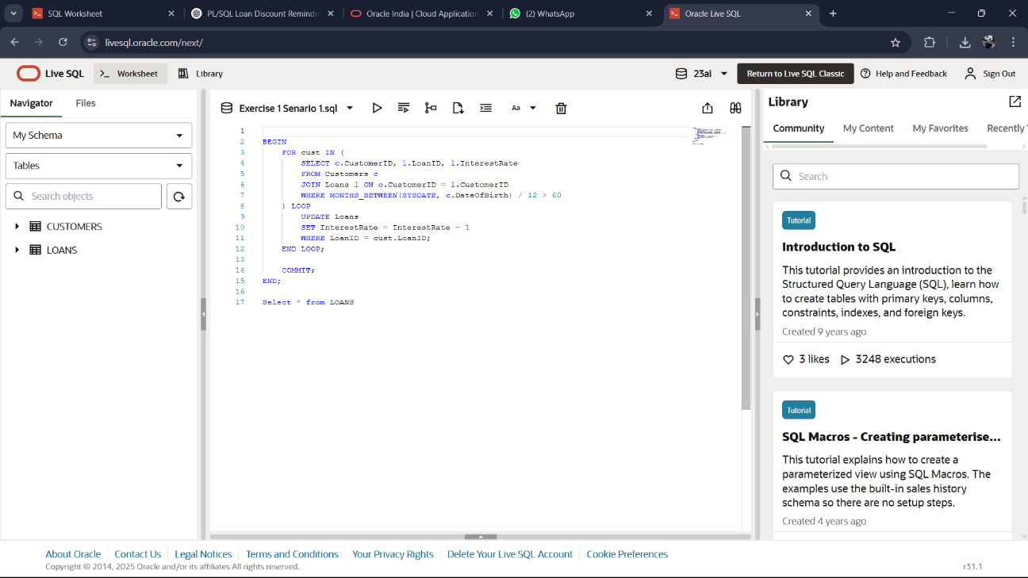

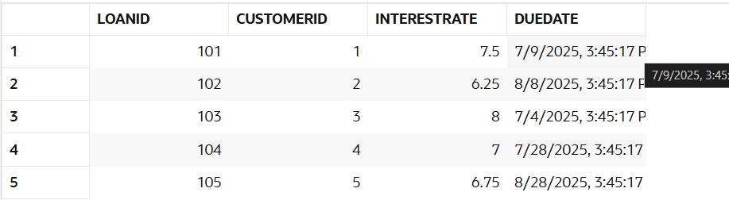

**Senario-2**

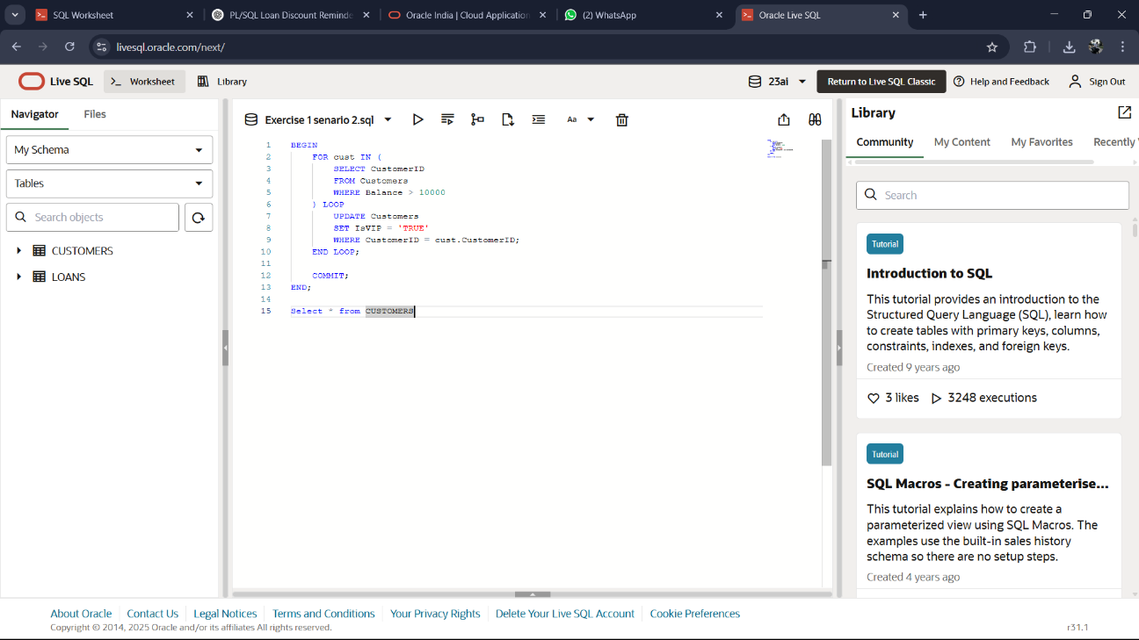

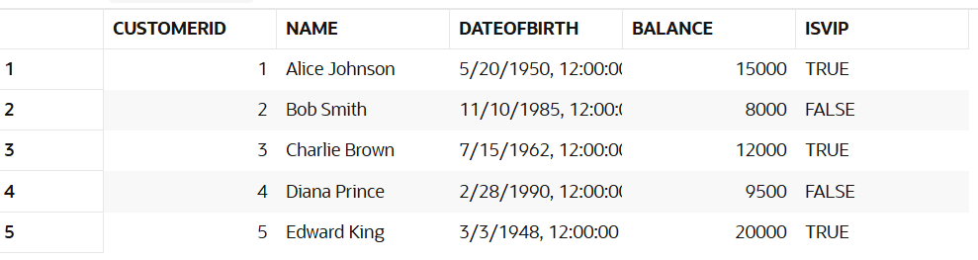

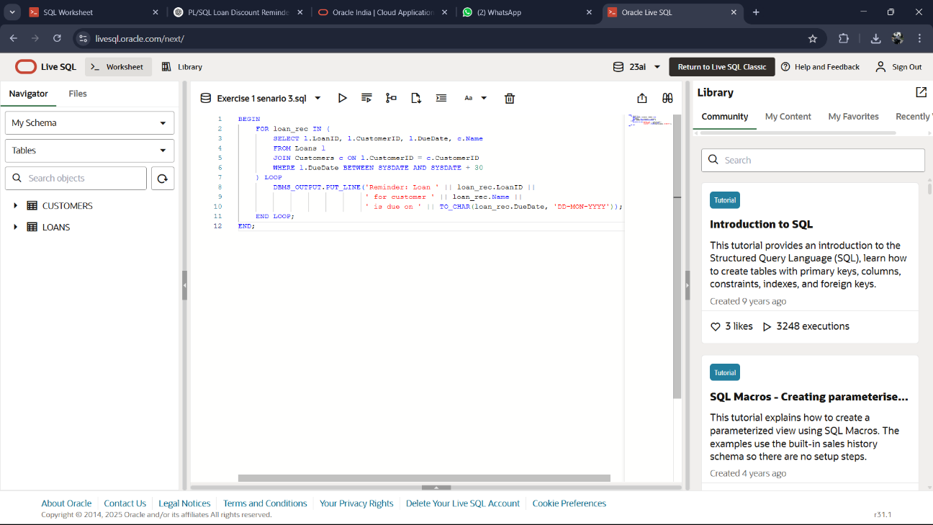**Senario-3**

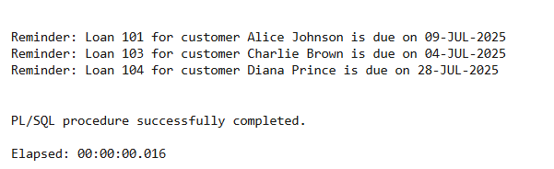

**Question-2(Stored procedures)**

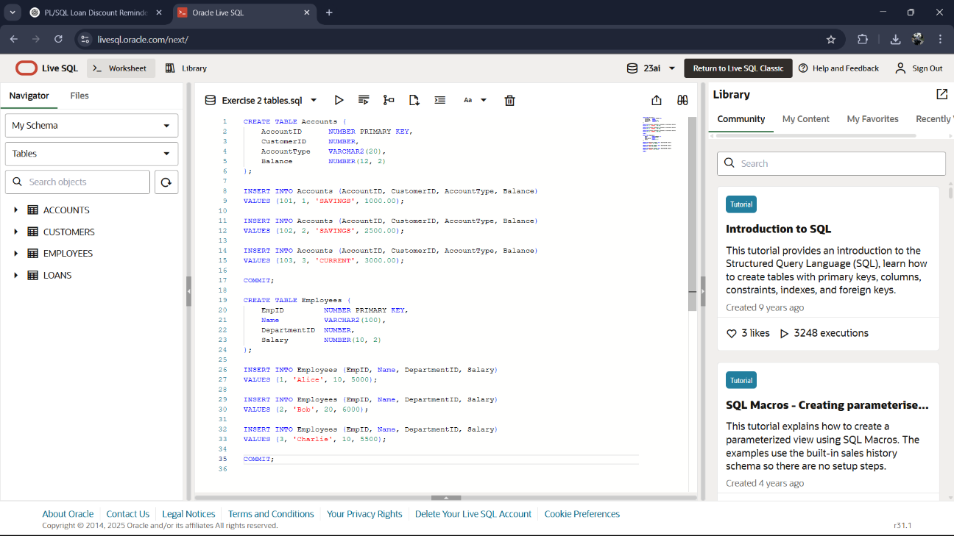**Create Table**

**Senario-1**

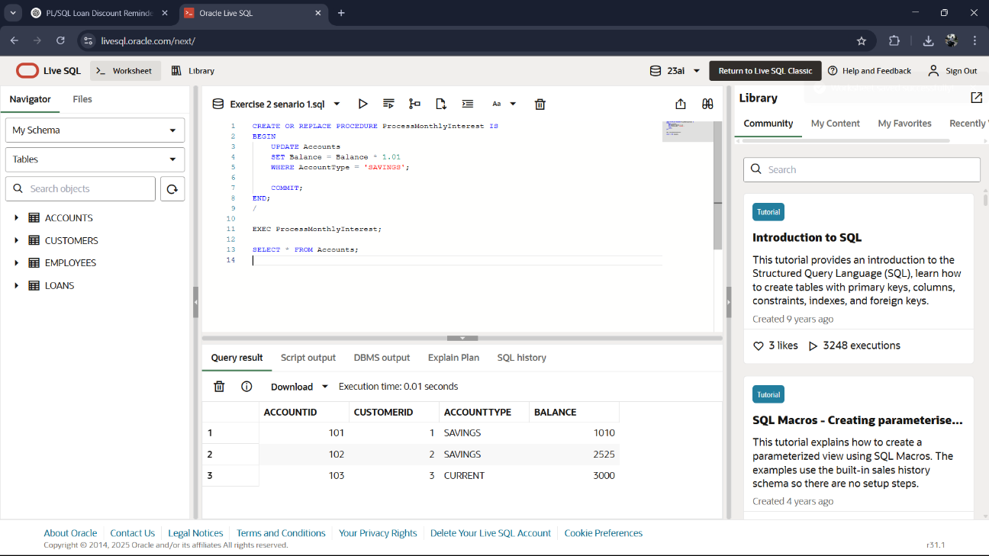

**Senario-2**

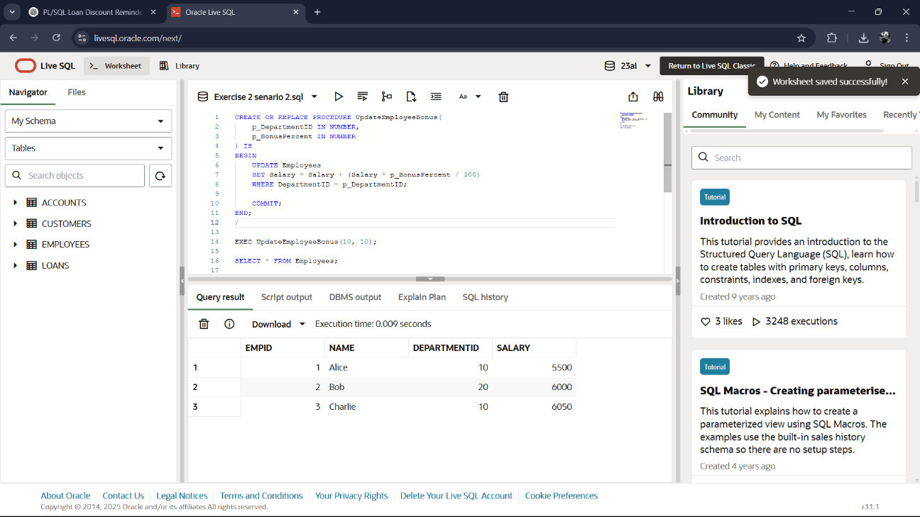

**Senario-3**

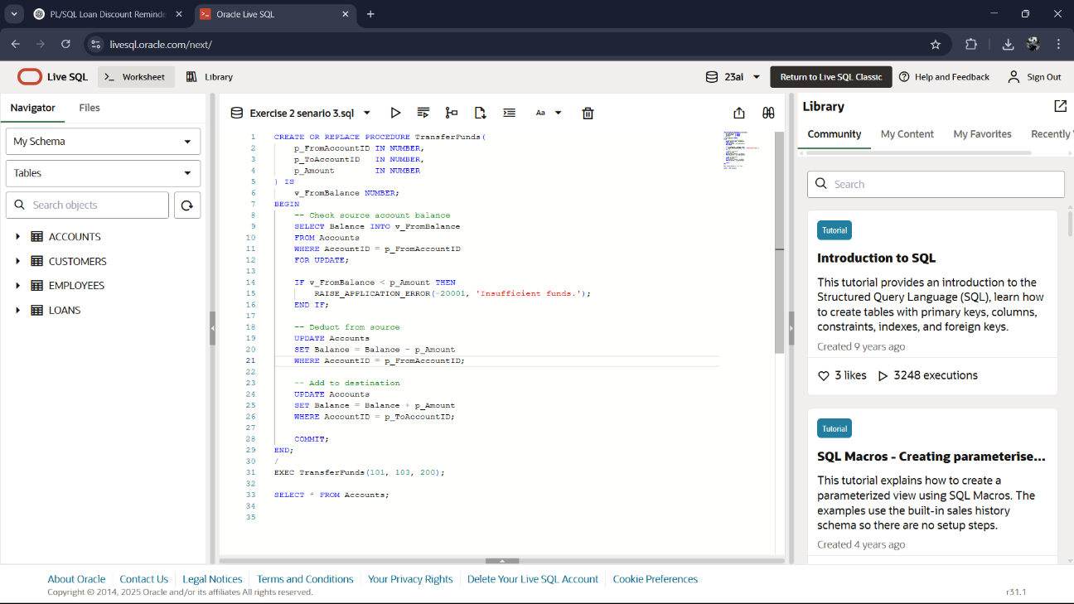

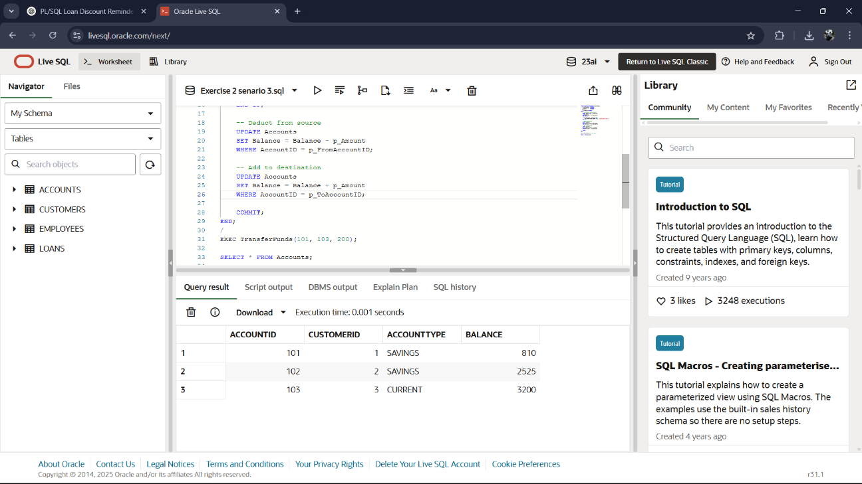

**Unit testing**

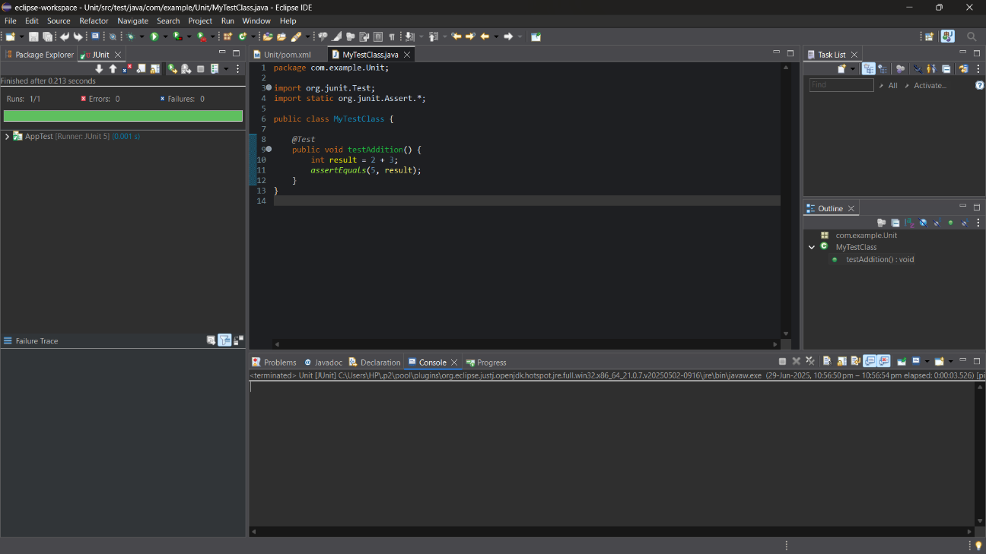**Question-1(Junit Testing)**

**Question-2(Assertions in Junit)**

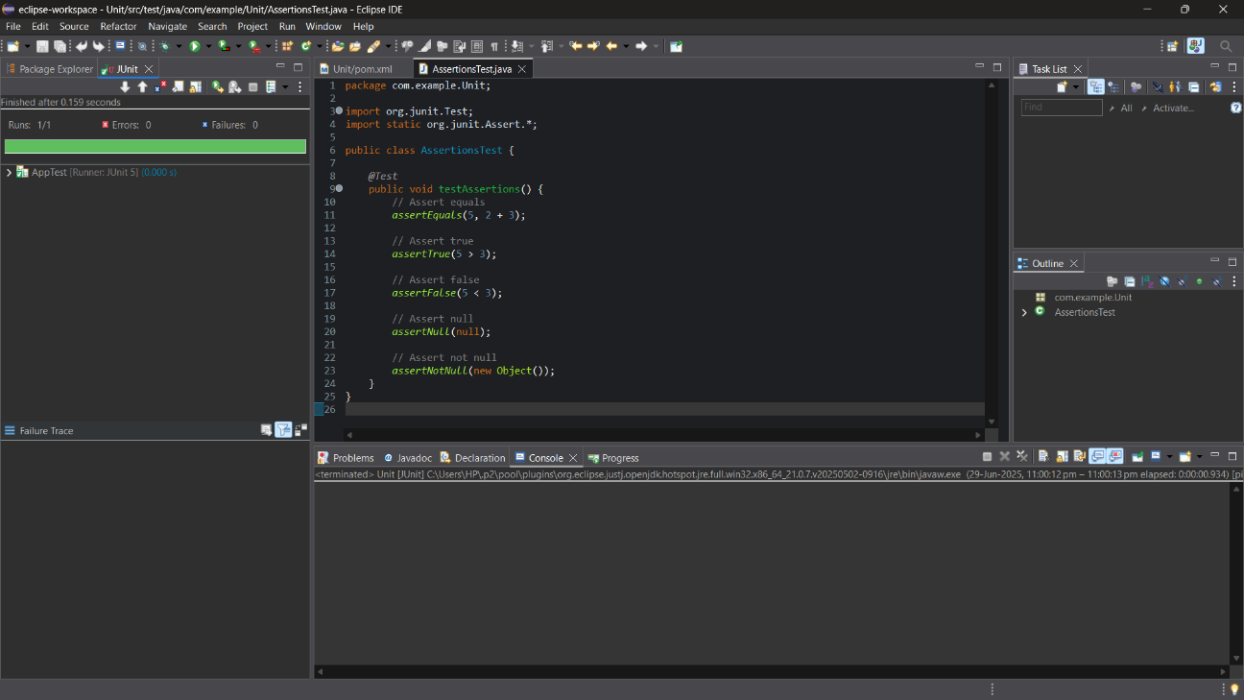

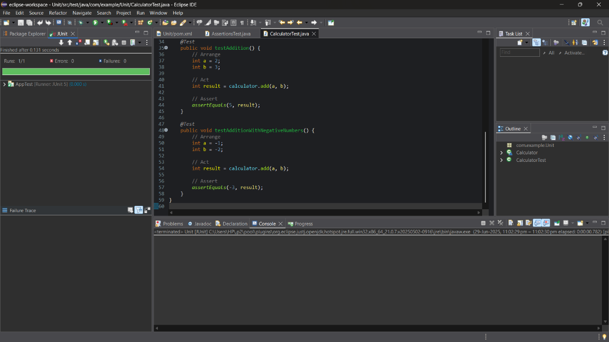**Question-3(Arrange-Act-Assert (AAA) Pattern, Test Fixtures, Setup and Teardown Methods in Junit)**

**Question-4(Mocking and Stubbing)**

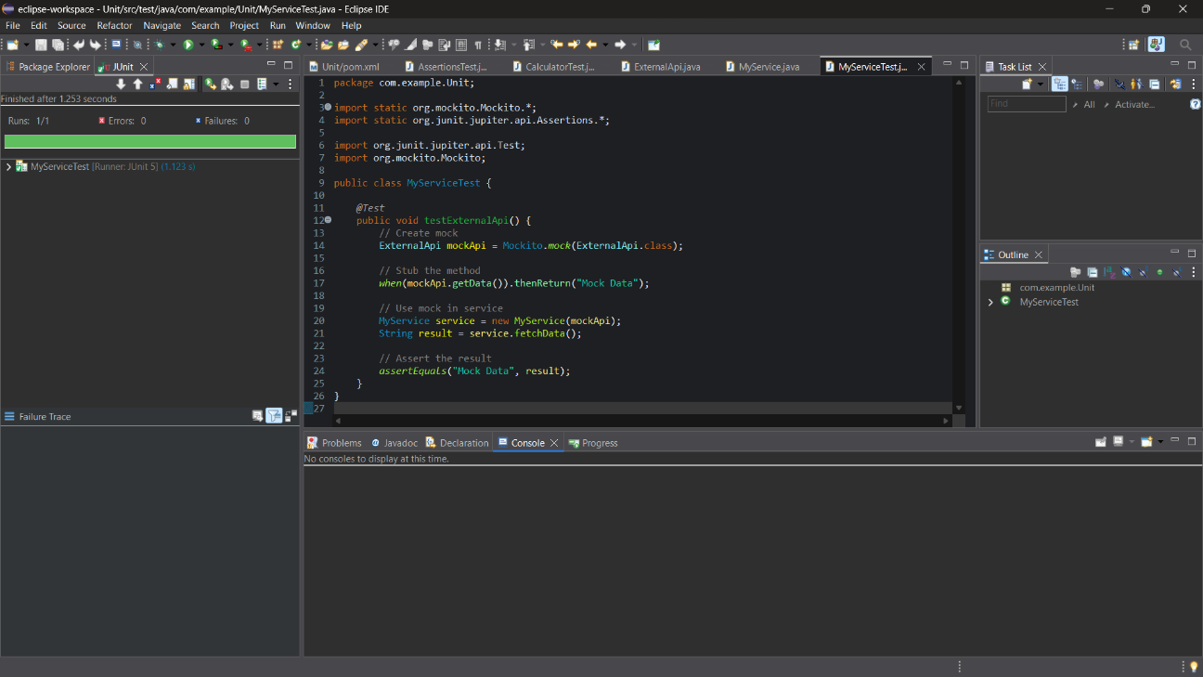

**Question-5(Verifying Interactions)**

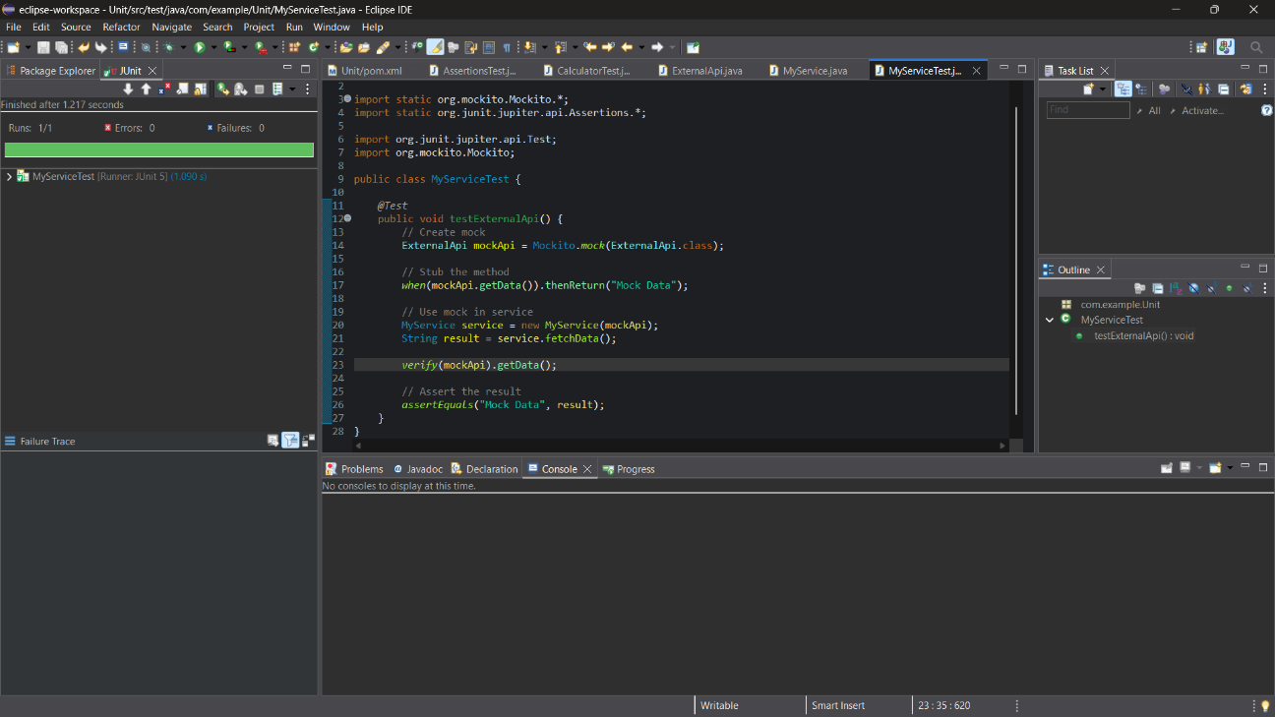

**Question-6(Logging Error Messages and Warning Levels)**

